Assignment-4

|  |  |
| --- | --- |
| Student Name | Selva kumar S |
| Batch No | B9 - 3A5E |
| Project Name | Personal Expense Tracker Application |
| Team ID | PNT2022TMID31819 |

Question-1:

pull an image from docker hub and run it in docker playground.pullan image form dockerhub

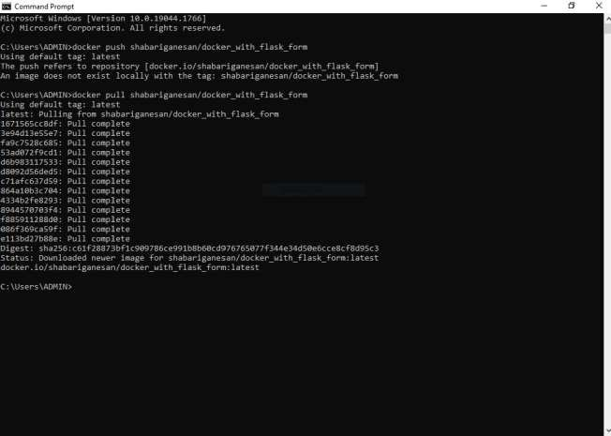

runtitindockerplayground

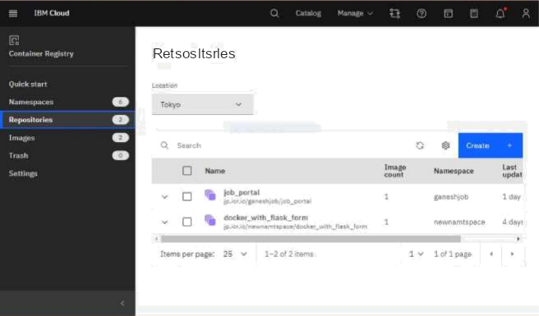

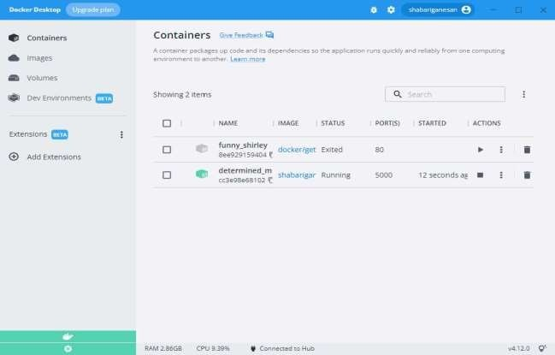

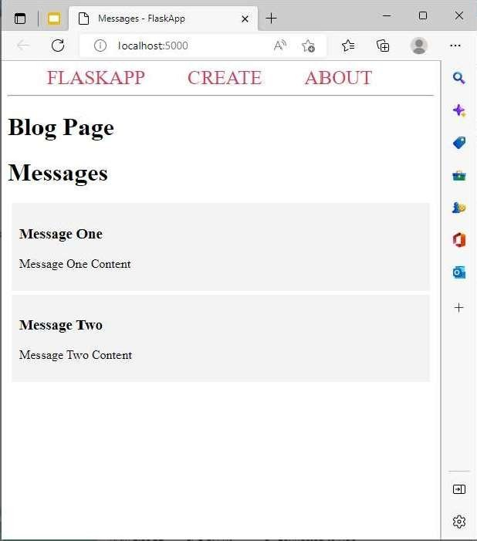

Question-2:

Createadockerfileforthejobportalapplicationanddeployitindockerapplication.

Creatingadockerfileforthejobportalapplication

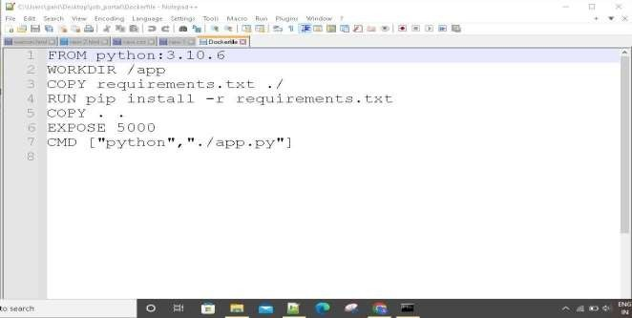

deployinindokcerapplication

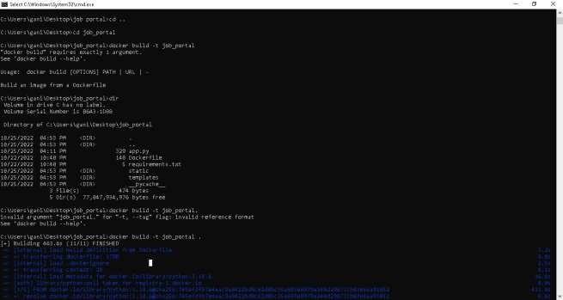

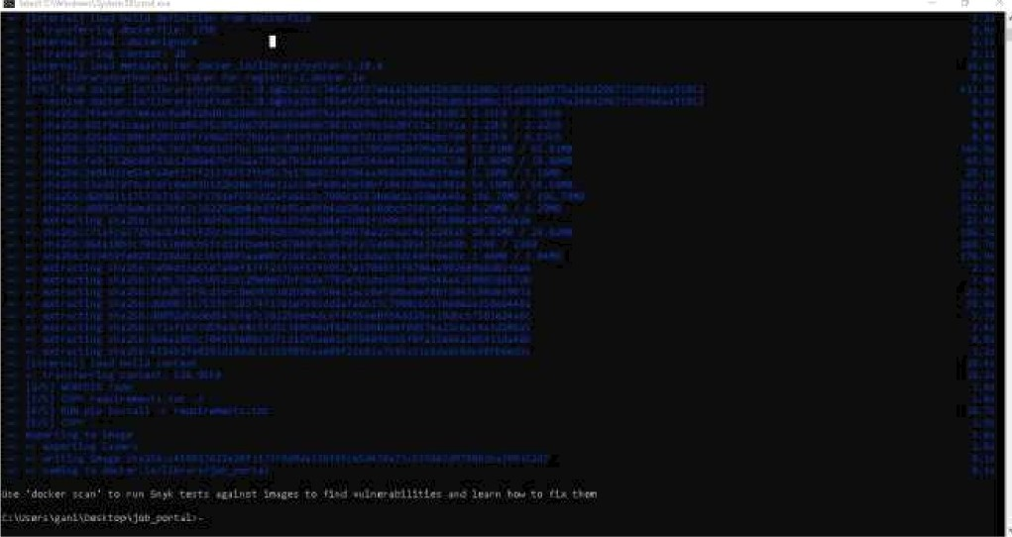



Cc rat ¿zi n e r S





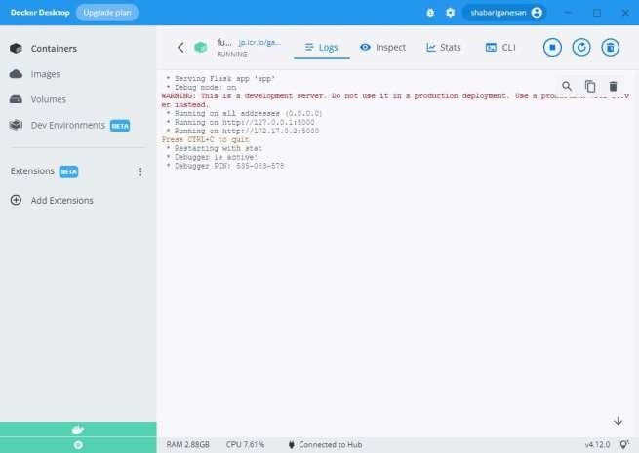



**runningindockerdesktop1**

Question-3:CreateaIbm containerregistry anddeploy helloworldapp orjobportalapp

createa ibm container registry



deployhelloworldorjobportal

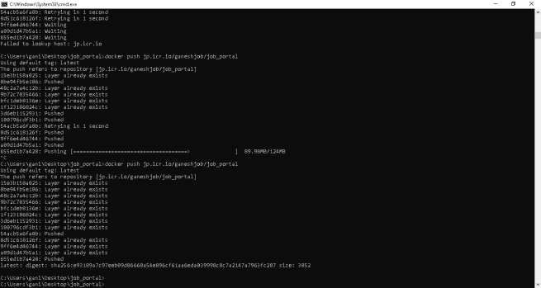





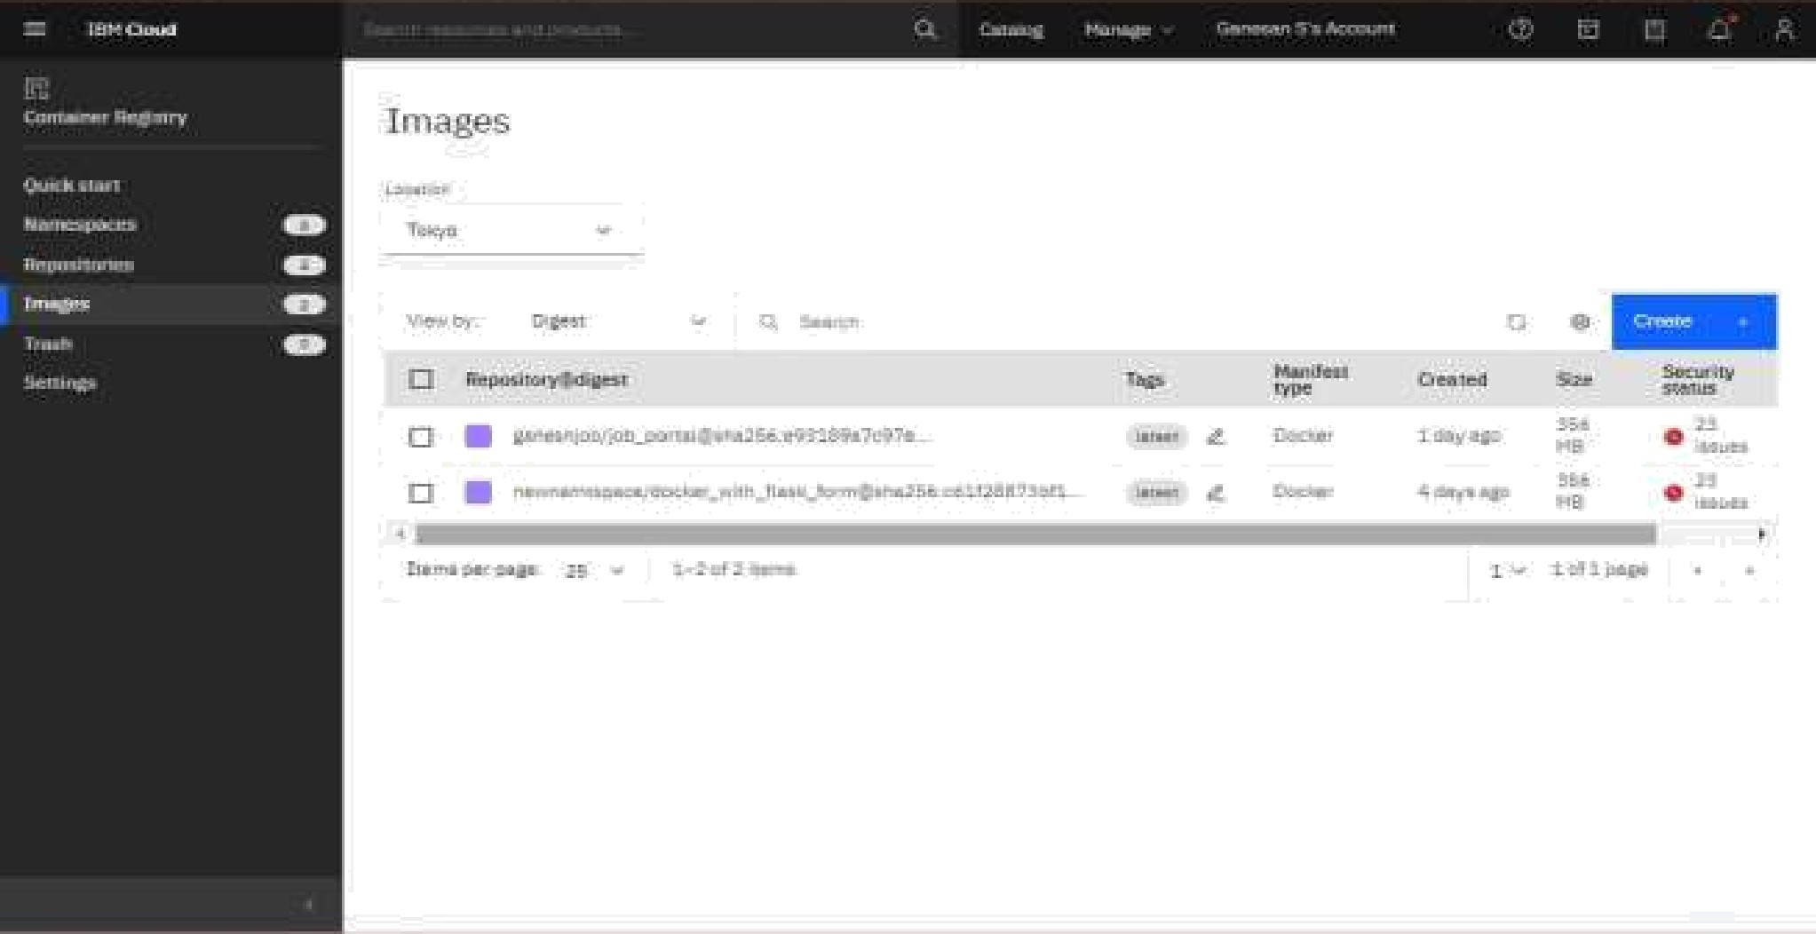

Question-4: Create a kubernetes cluster in ibm cloud and deploy helloworld image or jobportal image and also exposethesameapp to run in noteport

Creatingakubernetesclusterinibmcloud

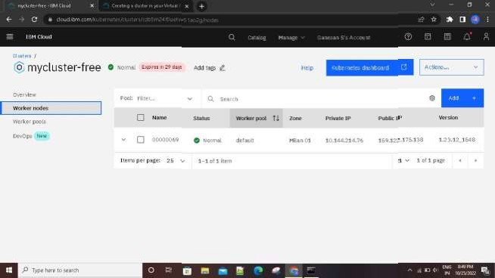

deployhelloworldimageorjobportalimageandalsoexposethesameapptoruninnoteport

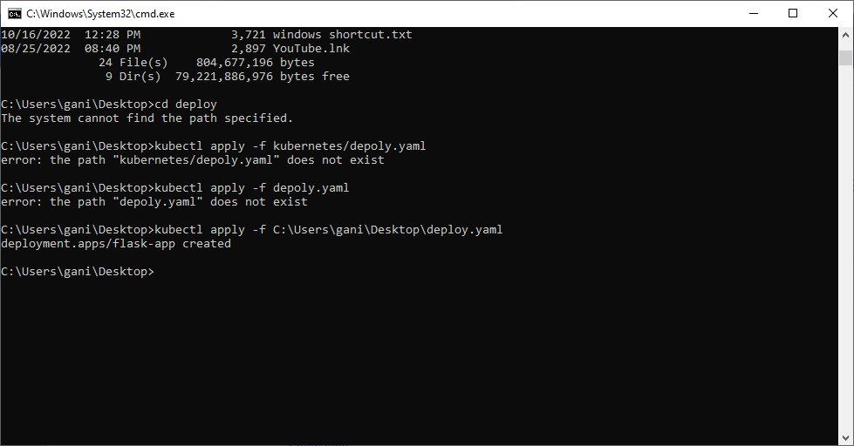











Wa1lin-gformoredalaadisplaycharl...Walingformoredata adisplaychart...





